Calorimeter
A calorimeter is a device that is in use for measuring the warmth of chemical reactions or physical changes also as heat capacity. The most common types of calorimeters are differential scanning calorimeters, titration calorimeters, isothermal micro calorimeters, and accelerated rate calorimeters. A normal calorimeter usually consists of a thermometer. This thermometer is again attached to a metal container filled with water suspended above a combustion chamber. It is one of the measurement devices useful in the study of thermodynamics, chemistry, and biochemistry.
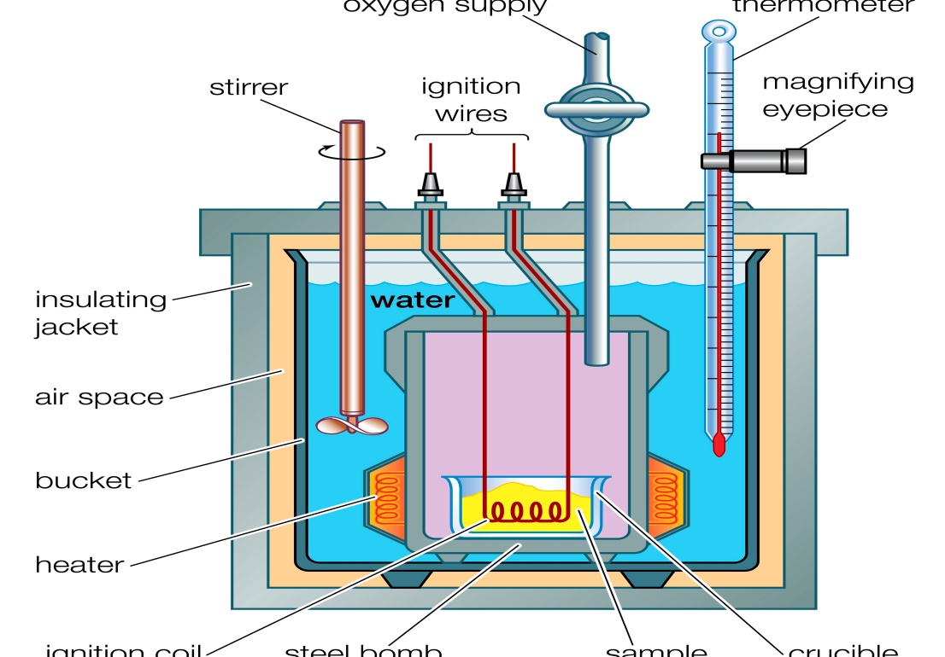
Procedure of Calorimeter
Now let us find the enthalpy change per mole of a substance A in a reaction between two substances A and B. Here, both the substances A and B, are separately added to a calorimeter and the initial and final temperatures (before the reaction has started and after it’s finished) are noted. Multiplying the natural process by the mass and heat capacities of the substances gives worth for the energy given off or absorbed during the reaction. Dividing the energy change by what percentage moles of A were present gives its enthalpy change of the reaction.
q = Cv (Tf−Ti)q = Cv (Tf−Ti)
Where q is that the amount of warmth consistent with the change in temperature measured in joules and Cv is that the heat capacity of the calorimeter which is measured in units of energy per temperature (Joules/K).

History
In 1761 Black introduced the thought of heat of transformation which causes the creation of the primary ice-calorimeters. In the year 1780, a French nobleman and chemist Lavoisier performed an experiment in which he used the warmth from the guinea pig’s respiration to melt snow surrounding his apparatus, showing that respiratory gas exchange is the combustion, almost like a candle burning.
Types of Calorimeter
Adiabatic Calorimeters
Adiabatic calorimeters measure the change in enthalpy of a reaction occurring in solution. During the reaction, the no heat exchange with the surroundings is allowed and the atmospheric pressure remains constant. An adiabatic calorimeter is a calorimeter which helps to examine a runaway reaction. As a result of an adiabatic environment, any heat generated by the fabric sample under test causes the sample to extend in temperature, thus fueling the reaction. The adiabatic calorimeter is actually a wrong term because it’s not fully adiabatic. Some amount of heat is usually lost by the sample to the sample holder. A mathematical correction factor, referred to as the phi-factor, are often used to adjust the calorimetric result to account for these heat losses.
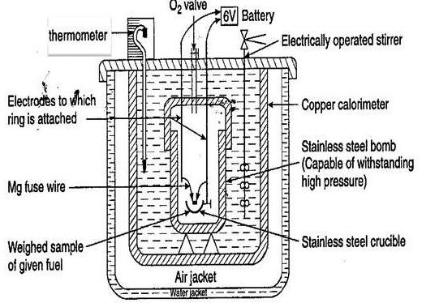
Reaction Calorimeters
A reaction calorimeter may be a calorimeter during which a reaction is initiated within a closed insulated container. Reaction heats are measured and therefore the heat content is obtained by integrating heat flow versus time. This is the quality utilized in industry to live heats since industrial processes are engineered to run at constant temperatures.
There are four, primary types of methods for measuring the warmth in reaction calorimeter:
1) Heat Flow Calorimeter – The cooling/heating jacket plays an important role in controlling either the temperature of the method or the temperature of the jacket. Heat is measured by monitoring the temperature difference between heat transfer fluid and therefore the process fluid.
2) Heat Balance Calorimeter – The cooling/heating jacket controls the temperature of the method. Heat is measured by monitoring the warmth gained or lost by the warmth transfer fluid.
3) Power Compensation – Power compensation uses a heater placed within the vessel to take care of a continuing temperature. The energy supplied to the present heater is often varied as reactions require and therefore the calorimetry signal is only derived from this electric power.
4) Constant Flux Calorimeter – Constant flux calorimetry (or COFLUX) springs from heat balance calorimetry and uses specialized control mechanisms to take care of a continuing heat flow (or flux) across the vessel wall.
Bomb Calorimeters
A bomb may be a sort of constant-volume calorimeter utilized in measuring the warmth of combustion of a specific reaction. Electrical energy is employed to ignite the fuel; because the fuel is burning, it’ll heat up the encompassing air, which expands and escapes through a tube that leads the air out of the calorimeter. When the air is escaping through the copper tube it’ll also heat up the water outside the tube. The temperature difference of the water allows for calculating the calorie content of the fuel.
In brief, a bomb consists of a little cup to contain the sample, oxygen, a chrome steel bomb, water, a stirrer, a thermometer, the dewar or insulating container (to prevent heat be due to the calorimeter to the surroundings) and ignition circuit connected to the bomb. By using chrome steel for the bomb, the reaction will occur with no volume change observed.
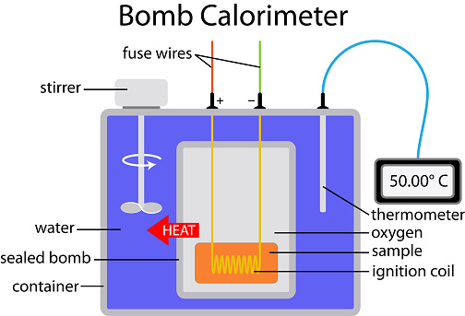

Calvet-type Calorimeters
The detection is predicated on a three-dimensional fluxmeter sensor. The fluxmeter element consists of a hoop of several thermocouples serial. The alternative thermopile having high thermal conductivity surrounds the experimental space within the calorimetric block. The thermopiles arranged radially guarantees an almost complete integration of the warmth. The calibration of the calorimetric detectors may be a key parameter and has got to be performed very carefully. For this Calvet-type calorimeters, a selected calibration, named as Joule effect or electrical calibration, has been developed and used to beat all sorts of issues.
The main advantages of this sort of calibration are as follows:
1) It is an absolute calibration.
2) The use of standard materials for calibration is not necessary. The calibration is often performed at a continuing temperature, within the heating mode and within the cooling mode.
3) It can be applied to any experimental vessel volume.
4) It is a very accurate calibration.
Differential Scanning Calorimeter
In this differential scanning calorimeter or DSC, heat flows into a sample which is usually contained within a small aluminium capsule or ‘pan’. This heat flow is measured differentially, i.e., by comparing it to the flow into an empty reference pan. The sample undergoing physical transformation (phase transition) has more or less heat flowing into it compared to the reference to maintain both at the same temperature. For e.g. Transition from solid to liquid involves more heat flowing to the sample to increase its temperature at the same rate as the reference. The calorimeter measures the amount of heat absorbed or released.
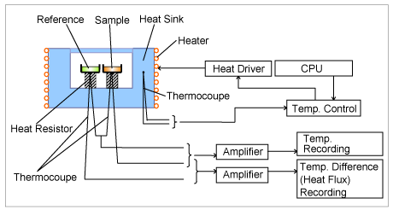
Isothermal Titration Calorimeter
This consists of 2 identical cells made of heat conducting but chemically inert material. The reference cell contains buffer or water while the sample cell contains the sample. Before adding the ligand for reaction power is given to the Reference cell which activates the heater in the sample cell. Ligand is then titrated causing an exo or endothermic reaction.
Exothermic- Temperature of the sample cell increase upon adding the ligand. Feedback power to the sample cell decrease to maintain equal temp between 2 cells.
In an isothermal titration calorimeter, the warmth of reaction is employed to follow a titration experiment. This technique is gaining high importance mainly within the field of biochemistry because it facilitates the determination of substrate binding to enzymes. The technique is usually utilized in the pharmaceutical industry to characterize potential drug candidates.
